VILLAGE OF MENANDS


MAYOR TRUSTEES

Brian Marsh Molly Harbour
Nicholas Kalogridis
VILLAGE CLERK Timothy Lane
Don Handerhan Lisa Neuman

Regular Village Board Meeting
June 15, 2026

The regular semi-monthly meeting of the Board of Trustees of the Village of Menands, held on Monday, June 15, 2026, was called to order by Mayor Brian Marsh at 6:00 P.M.

PRESENT:

Brian Marsh, Mayor
Molly Harbour, Trustee
Nicholas Kalogridis, Trustee
Timothy Lane, Trustee
Lisa Neuman, Trustee
Donald Handerhan, Village Clerk
Mary Jane Vredenburg, Village Treasurer
Stephen Rehfuss, Village Attorney
Ryan St. Gelais, Police Chief
Kevin Schwebke, Police Lt.
David Ognan, Fire Chief

Also attending: Bill Garvey, Mark Carnegie, Jason Carnegie, Mike & Susan MacKay, Dave Ognan, Jerry Ruppert, Kerry Franklin, Diane MacFarland, Steve Boulet, Jason Hoffman

Virtual attendance: PBA, Kathy Mosca, Mike Steurer, Beth & Paul Harbour

The Mayor led the Pledge of Allegiance and stated that this meeting is recorded.

Resolution Number: 260160

Trustee Harbour made a motion to accept the June 1, 2026, Village Board Meeting Minutes, seconded by Trustee Neuman.

ADOPTED:

Trustee Harbour voting AYE
Trustee Kalogridis voting AYE
Trustee Lane voting AYE
Trustee Neuman voting AYE
Mayor Marsh voting AYE

Resolution Number: 260161

Trustee Lane made a motion to approve payment for the following, seconded by Trustee Harbour.

WARRANTS :

ENCUMCBERED:
GENERAL totaling $ 25,824.79
WATER totaling $ 1,315.13
SEWER totaling $ 0.00
TOTALS $ 27,140.44

WARRANT JUNE 16, 2026
GENERAL totaling $ 26,486.40
WATER totaling $ 263,511.13
SEWER totaling $ 0.00
TOTALS $ 289,997.53

PAYROLL #2: totaling $100,717.58

ADOPTED:

Trustee Harbour voting AYE
Trustee Kalogridis voting AYE
Trustee Lane voting AYE
Trustee Neuman voting AYE
Mayor Marsh voting AYE

The Mayor notified the Board that Chief Ryan St Gelais, Lieutenant Kevin Schwebke, and the Mayor held interviews with Officer Alex Griffin and Officer Patrick Lurenz to fill the vacant Police roles. A comprehensive background investigation has been finalized.

Mayor Marsh appointed Officer Alex Griffin to the position of Full Time Police Officer at a salary of $79,352.00.

Resolution Number: 260162

Trustee Harbour made a motion to approve the appointed Officer Alex Griffin to the position of Full Time Police Officer at a salary of $79,352.00, seconded by Trustee Lane.

ADOPTED:

Trustee Harbour voting AYE
Trustee Kalogridis voting AYE
Trustee Lane voting AYE
Trustee Neuman voting AYE
Mayor Marsh voting AYE

Mayor Marsh appointed Officer Patrick Lurenz to the position of Part Time Police Officer at a salary of $44.37 per hour.

Resolution Number: 260163

Trustee Harbour made a motion to approve the appointed Officer Patrick Lurenz to the position of Part Time Police Officer at a salary of $44.37 per hour, seconded by Trustee Kalogridis.

ADOPTED:

Trustee Harbour voting AYE
Trustee Kalogridis voting AYE
Trustee Lane voting AYE
Trustee Neuman voting AYE
Mayor Marsh voting AYE

Mayor Marsh gave the following update of the South End Project:
- Sewer mains are being installed on Wolfert Ave.
- Storm Mains are being installed on Amsterdam Ave.
- National Grid will be holding poles while Storm Main is installed.
- There have been complaints that School bus can not go through the construction area. The Bus Drivers are not attempting to go through the area. The Bus company has been advised.
- There are detours in effect, but local traffic is allowed.
- There will be a detour soon to be in effect, but local traffic is allowed. (Both Amsterdam/Wolfert will be affected)
- Approximately 2 weeks from today when the Amsterdam full depth Road Demolition/Rebuild begins.

Mayor Marsh gave the following update on the Fire at 250 Broadway:
- Currently, the cause of the fire remains under active investigation by the Town of Colonie Department of Fire Services, the New York State Office of Fire Prevention and Control, and private investigators retained by the Village’s insurance carrier. No official determination regarding the cause or origin of the fire has been made.
- We recognize the significant interest this incident has generated throughout our community and beyond. Investigators continue to comprehensively examine the scene, and this process will take time, possibly months, to ensure that all relevant facts are carefully reviewed. We respectfully ask the public to refrain from speculation and allow investigators to complete their work.
- The Village remains committed to transparency and will provide updates as information becomes available and can be appropriately released. Any official announcements will be shared through press releases and social media from the communication channels of the Village of Menands, the Menands Police Department, and the Menands Fire Department.
- We extend our sincere gratitude to our residents, neighboring fire departments, emergency service agencies, local businesses, and community members for their continued support, patience, and generosity during this challenging time. The outpouring of assistance and encouragement has been deeply appreciated by everyone affected.
- The Menands Fire Department continues to provide emergency services to the community without interruption. We remain confident in our ability to meet the needs of our residents while recovery efforts continue.
- Schuyler Heights Fire Department has donated their Fire House and Equipment to the Fire Department.
- Shaker Road and Albany County Fire Coordinator have donated the use of Fire Engines that are housed at DPW.
- The Menands Police has opened a station on the 3rd floor of the Riverview Center.
- A Trailer has been ordered to for the Patrol Officers to use.

The Clerk gave an update on the Get the Lead Out Survey:
- The Get the Lead Out Team with the assistance of Mark Carnegie and Tim Lane Knocked on Doors in every neighborhood in the Village.
- The last survey will be completed in July.
- The GLO Team findings as of June 11, 2026:

May June
469 Properties 469 Properties

Copper 115 138
Galvanized 7 9
Lead 8 2
Plastic 2 6
Likely Copper 1 0
Cast Iron 0 3
Unknown 7 3
Inaccessible 0 5
Total 140 166
Access Rate 30% 36%
No Answer 271 231
Declined 35 23
Come Back 19 9
Vacant 4 17
Does Not Exist 0 13

The Clerk advised that GLO Team will be returning in July.

Mayor Marsh advised the Board that New York State Environmental Facilities Corporation that administer Water Grants has moved the grant application deadline from September to July for the replacement of the high service reservoir . The Bonding will have to moved up also. Discussion followed.

Mayor Marsh read the following from LaBella:

On March 23, 2026, the Albany County Department of Health (ACDOH), in conjunction with the New York State Department of Health (NYSDOH), conducted a sanitary survey of the Village of Menands public water system and identified multiple significant deficiencies associated with finished water storage infrastructure, sanitary protection, facility security, and system operations. In response to the sanitary survey findings and associated violation letter, the Village developed and submitted a Corrective Action Plan (CAP) to ACDOH and subsequently prepared a Preliminary Engineering Report (PER) for the proposed “Village of Menands Critical Water Source and Storage Improvements Project” as part of a Water Infrastructure Improvement Act (WIIA) funding application through the New York State Environmental Facilities Corporation (EFC).
As part of the WIIA funding application process, compliance with the State Environmental Quality Review Act (SEQRA) is required. Therefore, this memorandum documents the SEQRA review process completed for the proposed project and provides the basis for the recommended SEQRA classification determination.

Project Scope:
The proposed Critical Water Source and Storage Improvements Project consists of improvements to existing municipal water system infrastructure owned and operated by the Village of Menands. The project includes replacement of the existing deteriorated High Service Reservoir at the existing reservoir site; sanitary protection and security improvements to the existing Low Service Reservoir; replacement of inoperable valves and associated piping modifications within the existing Wards Pump Station; and installation of a limited interconnection between the Village water distribution system and the Albany Water Board water system to improve operational flexibility and emergency supply resiliency.

The High Service Reservoir component includes demolition and replacement of the existing buried concrete finished water reservoir with a new finished water storage tank at the existing facility location. Associated improvements include replacement of appurtenant piping, controls, access structures, security measures, and related site improvements necessary to restore compliant operation of the existing facility. The Low Service Reservoir improvements consist of above-grade access modifications, replacement of access hatches, security fencing, gates, and monitoring equipment at an existing municipal water storage facility. The Wards Pump Station improvements consist of replacement of existing inoperable valves and minor associated piping modifications entirely within the existing pump station facility.

The proposed Albany Water Board interconnection consists of installation of approximately 100 linear feet of new water main, associated valves, metering, controls, and appurtenances within previously disturbed roadway and utility corridor areas to provide operational redundancy and emergency interconnection capability between existing public water systems. No expansion of the Village water service area, creation of new water districts, extension of service to undeveloped areas, or increase in permitted source capacity is proposed as part of the project.

The proposed work is limited to replacement, rehabilitation, repair, upgrading, and modernization of existing municipal water system infrastructure at existing facilities and within existing developed utility and roadway corridors. The project is intended to address documented regulatory deficiencies, restore compliant finished water storage, improve sanitary protection, improve operational reliability, and reduce ongoing maintenance and emergency repair needs associated with aging infrastructure.

Recommendation of Determination:
Based upon the proposed scope and nature of improvements, it is LaBella Associates’ recommendation that the project be classified as a Type II Action pursuant to the State Environmental Quality Review Act (SEQRA). Type II Actions are not subject to further review under SEQRA pursuant to 6 NYCRR Part 617.5. The proposed action is consistent with one or more of the following Type II classifications contained within 6 NYCRR 617.5(c):

- maintenance or repair involving no substantial changes in an existing structure or facility;

- replacement, rehabilitation, or reconstruction of a structure or facility, in kind, on the same site, including upgrades necessary to meet current codes, regulatory requirements, and design standards, unless such action meets or exceeds any threshold contained in 6 NYCRR 617.4;

The proposed project will not involve creation of new water districts, substantial expansion of system capacity, extension of service to undeveloped areas, significant disturbance to undeveloped land, or other actions that would warrant a Type I determination pursuant to 6 NYCRR 617.4. Work will occur at existing municipal water infrastructure sites and within previously disturbed roadway and utility corridors, with all disturbed areas restored following construction.

Therefore, it is LaBella Associates’ opinion that the proposed Critical Water Source and Storage Improvements Project constitutes a Type II Action under SEQRA and is not subject to further environmental review.

Resolution Number: 260164

Trustee Lane entered the following resolution:

STATE ENVIRONMENTAL QUALITY REVIEW ACT RESOLUTION FOR THE
VILLAGE OF MENANDS CRITICAL WATER SOURCE AND STORAGE IMPROVEMENTS PROJECT
WHEREAS, the Village Board of Trustees of the Village of Menands (the “Board”) is considering the following proposed scope of work:
The Village of Menands proposes improvements to existing municipal water system infrastructure intended to address significant deficiencies identified during the March 23, 2026, sanitary survey, restore compliant finished water storage, improve sanitary protection, improve operational resiliency, and protect public health. The proposed project includes replacement of the existing deteriorated High Service Reservoir at the existing reservoir site; sanitary protection and security improvements to the existing Low Service Reservoir; replacement of inoperable valves and associated piping modifications within the existing Wards Pump Station; and installation of a limited interconnection between the Village water distribution system and the Albany Water Board water system to improve operational flexibility and emergency supply resiliency. The proposed work will occur at existing municipal water infrastructure sites and within existing roadway and utility corridors.
WHEREAS, the Board has reviewed the scope of the project and has further received and considered the advice of its engineers and environmental professionals with respect to classification of the action in accordance with the State Environmental Quality Review Act (SEQRA); and
WHEREAS, the Board has reviewed the Proposed Action with respect to the Type II criteria set forth in 6 NYCRR Part 617.5(c), including the following:
- maintenance or repair involving no substantial changes in an existing structure or facility; and
- replacement, rehabilitation or reconstruction of a structure or facility, in kind, on the same site, including upgrades necessary to meet current codes, regulatory requirements, and design standards, unless such action meets or exceeds any threshold contained in 6 NYCRR 617.4,
WHEREAS, the proposed project consists of replacement, rehabilitation, repair, upgrading, and modernization of existing municipal water system infrastructure at existing facilities and within previously disturbed roadway and utility corridors and does not involve creation of new water districts, extension of service to undeveloped areas, or substantial expansion of system capacity; and
WHEREAS, the proposed project is a Type II action meeting one or more of the aforementioned Type II criteria; and
WHEREAS, Type II actions have been determined not to have a significant impact on the environment and are not subject to further review under SEQRA;
NOW, THEREFORE, BE IT RESOLVED, that the Village Board of Trustees hereby determines that the proposed Village of Menands Critical Water Source and Storage Improvements Project constitutes a Type II Action under SEQRA, and that no further environmental review is required.

Second By Trustee Harbour.

ADOPTED:

Trustee Harbour voting AYE
Trustee Kalogridis voting AYE
Trustee Lane voting AYE
Trustee Neuman voting AYE
Mayor Marsh voting AYE

The Clerk Gave an update the Village Website options:

Here is a clear breakdown of the website-related costs for the Village of Menands and show how they would apply under two different scenarios.
There are a few required annual costs that would apply regardless of whether your staff handles content updates or Next Step Digital handles them.
Required Costs
These costs are necessary either way:
- Firewall: $400 per year
- Annual Hosting: $600 per year
- Monthly Platform and Plugin Updates + Backups: $1,200 per year
This includes approximately 1 hour per month for WordPress, platform, plugin, and backup maintenance.
Scenario A: Village Staff Handles Content Updates
If Village staff would like to handle the day-to-day content updates internally, the required costs above would still apply. In addition, there would be one-time costs for documentation and training:
- WordPress Documentation: $700 one-time
- Training: $200 one-time
Under this scenario, the Village would be responsible for making its own content updates after training is completed. Additionally, Next Step would bill in quarter hour increments for any phone calls or email support time that would be necessary if your staff required assistance while doing the updates.
Scenario B: Next Step Digital Handles Content Updates
If the Village would prefer for Next Step Digital to handle day-to-day website content updates, we can provide that service through a quarterly maintenance retainer.
- Monthly Value: $500
- Quarterly Billing: $1,500 billed in advance at the start of each quarter
- Annual Total for Content Updates: $6,000
This would be in addition to the required costs listed above, including firewall, hosting, and monthly platform/plugin updates and backups.

Discussion followed. Tabled to next meeting.

Mayor’s Report:
- The Village as received over 200 applications to fill Cheryl Lyons position as Accounting Clerk. Two interviews have been completed.
- Assemblyman Phil Steck and the Mayor will be at the Capital District Regional Market on June 17, 2026, at 11:00 to welcome them into the Historic Business Registry.
- Albany Rural has a Flyer of upcoming events available in the Village Office.
- The Village still has not received any monies from the Town of Colonie Court.
- Carly Darmetko was the recipient of the Sara Maldonado Scholarship
- A letter regarding Solar Simplified will be sent with the Water Bills

Trustee’s Report:

Neuman:
- The Menands Library will be kicking off Summer Reading program this Saturday June 20, 206
- The Library is looking for Library Assistant.

Kalogridis:
- Met with the new CEO of CDTA and discussed improvements to Village Bus Stops and a sidewalk for Wards Lane.
Lane: No Report

Harbour:
Menands Seniors
- This will be their first meeting since the fire, and they will be meeting at 9 a.m. at the crossings. This week there will be yoga, bingo, and pizza.
- The next business meeting will be on June 25th
Menands School-
- On June 2, two dozen Menands School choir members in grades 6–8 participated in the American Young Voices event at MVP Arena, joining hundreds of students from across the region for a 90-minute national sing-along. The event followed an international virtual singalong earlier this year, where more than 350,000 singers from 30 countries performed the same specially arranged Wicked medley as part of a global celebration of music.
- June 5 was field day. Great weather, but the firemen were missed by all the kids, and I look forward to getting them back there next year
Upcoming!
- PTA - 16 Handles Fundraiser!
  - When: Wednesday, June 17th
  - Where: 593 N Greenbush Rd, Rensselaer
  - Time: 5 pm - 6:30 pm
  - 16% of the proceeds will be donated to the Menands School PTA! No Flyer needs to be shown with the purchase.
- 2nd Grade Field Trip- due to the fire the kids were unsure that they would have a field trip, but a special thank you to the fire department and police department for making alternative plans and ensuring the kids get their field trip
- New Date! Menands 6-8th Grade Dance Red Carpet
  - When: The Middle School Dance will now be on Thursday, June 18th! 6 pm
- No School Friday, June 19th, in honor of Juneteenth
  - The building will be closed.
- Several celebrations will bring the school year to a close in Menands.
  - On June 18, several seniors will return to the grades PreK-8 school to do a senior walk through the halls as current students watch and cheer them on.
  - On June 22, a 5th-grade moving-up celebration
  - On June 23, kindergarten students will be celebrated with a moving-up ceremony
  - On June 24, PreK students will be celebrated with a moving-up ceremony
  - On June 25, a graduation ceremony will be conducted at 6 p.m. for 8th graders as they depart the halls of Menands for area high schools.
- July 7th will be the school board reorganizational meeting

Clerk’s Report:
- The next meeting will be the Organizational Meeting
- On Thursday June 18, 2026, at 6 PM in the Library of Menands School there will be a ZBA Hearing regarding construction of a home at 35 Clifford Rd.

Treasurer’s Report:
- Working on Annual Financial Report of 2025-2026
- Water Bills will be going out in July

Fire Chief David Ognan advised the Board he has received the following quote from DeNoyer Chevrolet to purchase a new Fire Chief’s vehicle under New York State Contract:
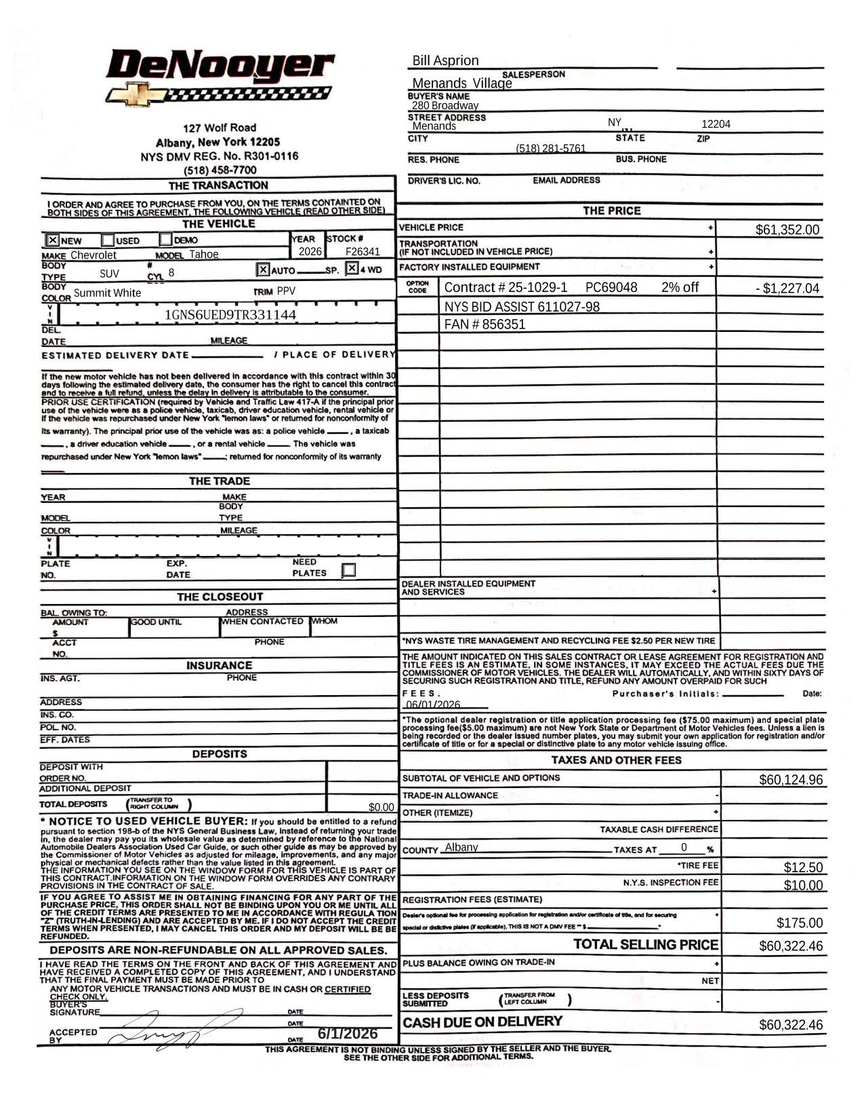
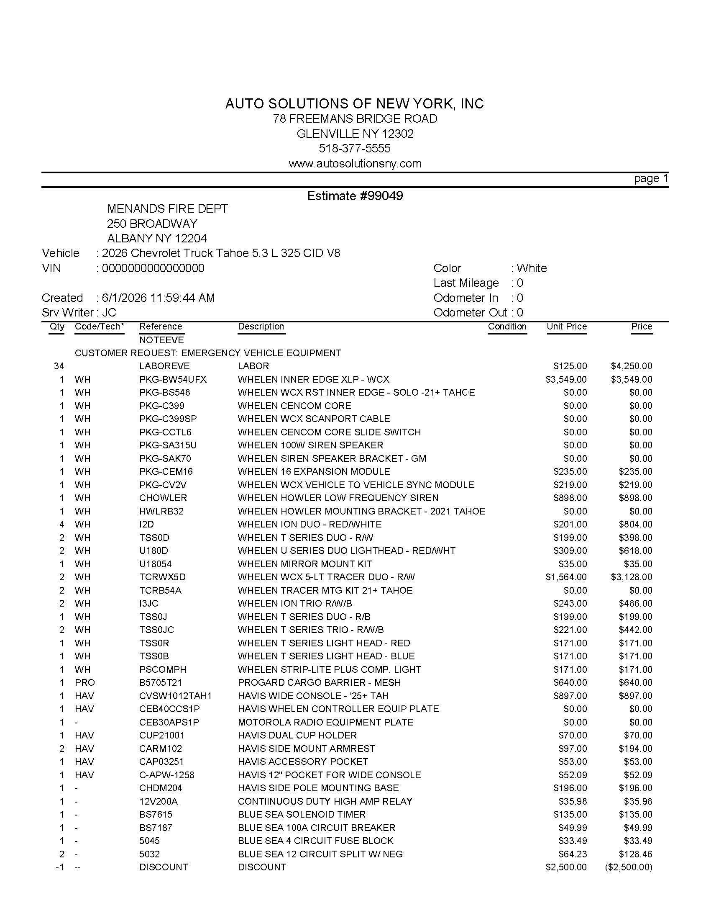
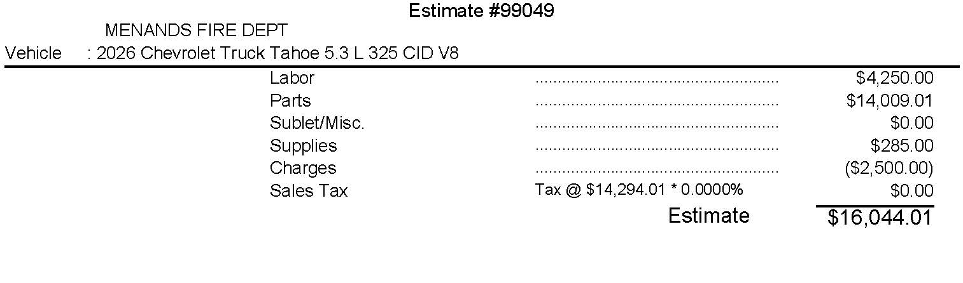

Discussion followed.

Resolution Number: 260165

Trustee Harbour made a motion to accept the quote of $60,322.46 to purchase a 2026 Chevrolet Tahoe from DeNoyer Chevrolet under New State Contract and $16,444.00 for Auto Solutions to upfit the Tahoe, seconded by Trustee Neuman.

ADOPTED:

Trustee Harbour voting AYE
Trustee Kalogridis voting AYE
Trustee Lane voting AYE
Trustee Neuman voting AYE
Mayor Marsh voting AYE

David Ognan advised the Board and the residents requested that residents volunteer for lead and copper testing via a Google form, emphasizing that the process is straightforward for participants.
Discussion followed.

General Comments:

Resident Bill Garvey:
- Supports Solor Energy Permits
- Supports Lawn Irrigation Permits
- Happy to see the potholes near the Brookside Railroad crossing were repaired
- Removed bush from a fire hydrant on N Lyons
- Is very upset that The Town of Colonie hasn’t sent reimbursements owed from the Court
- Supports the new fee Schedule
- Reported a soap dispenser in the Men’s Room not working
- Removed brush from railing at 33 Menand Rd
- Clean up broken glass from Clifford Rd
- Cleaned the door in front of the Police Department
- Sorry to hear that Schuyler Heights has closed
- The Village Residents should be happy that the Village Fire Department is not short of manpower
- Completed cleaning at Ganser Smith Park
- Observed several signs covered by weeds

Resident Pat Brundage asked what a resident is responsible for if their sewer or water line needs to be replaced. The Mayor advised the resident is responsible from the main to the home.

Resident Bill Quackenbush expressed his concern regarding Village spending.

Resident Steve Boulet gave the Board some options to help with the website.

Resident Jerry Ruppert advised the Village should reach out to Chuck Price for website advise.

A motion was made by Trustee Neuman to adjourn, seconded by Trustee Harbour.

ADOPTED:

Trustee Harbour voting AYE
Trustee Kalogridis voting AYE
Trustee Lane voting AYE
Trustee Neuman voting AYE
Mayor Marsh voting AYE

The meeting was duly adjourned at 7:00 P. M.

I Donald Handerhan, Village Clerk for the Village of Menands, Do Hereby Certify that the foregoing is a true and correct report of all motions and resolutions and or enacted, and all other procedures had and taken by the Village of Menands Board of Trustees at the regular meeting held on June 15, 2026.

_____________________
Donald Handerhan
Village Clerk

